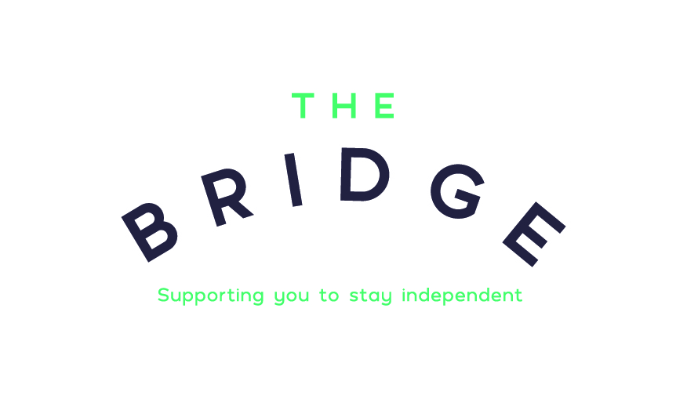

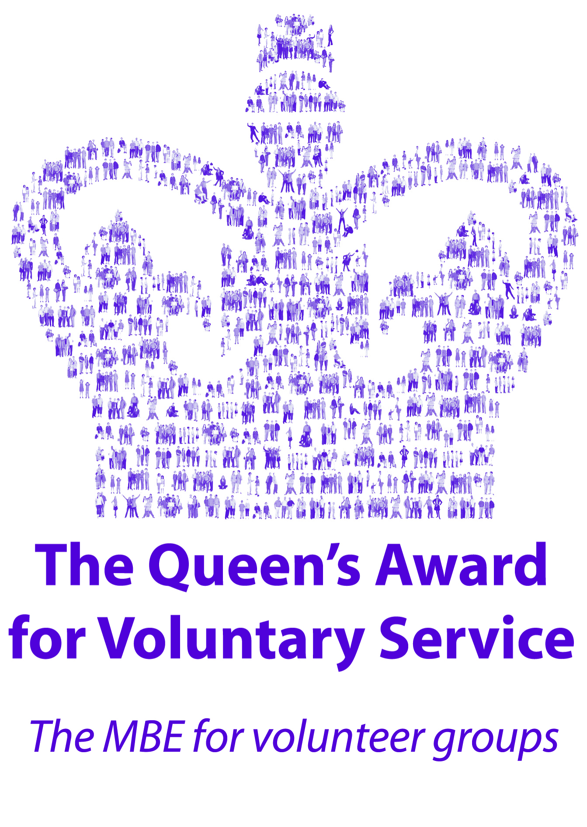

**” BRIDGING THE GAP FOR OLDER PEOPLE”**

* ***Day Service*** - A service for older people, giving families piece of mind their loved one is in safe hands, receiving a nutritious meal and enjoying meaningful daily activities. Also, a great, safe environment for people who have dementia.

You can come one, two or three days a week – Monday, Wednesday or Friday.

**The cost is £39.50** per day – this service covers Catterick and surrounding villages.

* **Respite Drop-in Service for people with Dementia**

Are you a carer looking after someone who has dementia? Do you need to attend the dentist? A hospital appointment? Need to go shopping? Or would like to continue to meet up with friends for a coffee?

**We can help –** drop your loved one off at The Bridge for an hour or two and be assured they are being looked after in a warm caring environment.

**The cost is** **£15** per hour - Own transport is needed to get here.

* ***Sitting Service*** - A service to give the carer time to themselves on a regular basis; weekly, fortnightly or monthly. A volunteer is placed to sit with your loved one whilst you are free to do as you please for a couple of hours or so!

**This is a free service** –this servicecovers the whole of **Richmondshire**

**IF YOU WOULD LIKE TO FIND OUT MORE PLEASE CONTACT US:**

Shute Road - Catterick Garrison - North Yorkshire - DL9 4AF

[info@thebridge-richmondshire.com](mailto:info@thebridge-richmondshire.com) Tel: 01748 832271 [www.thebridge-richmondshire.com](http://www.thebridge-richmondshire.com)

**Facebook:** The Bridge Shute Road **Twitter:**  @TheBridge_2018

Registered Charity No: 1154379